1. The opposite of split is **Aggregation**.
2. camel-microservice-a doesn’t have the following dependency. Let’s add.  
   
3. 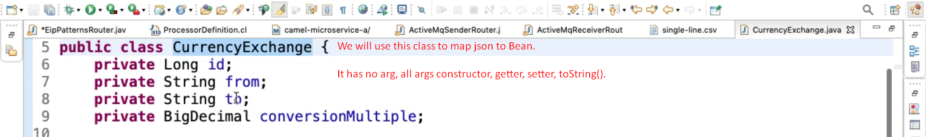
4. Actually, before starting writing code, let’s understand what we want to achieve.   
   We will have 6 JSON files each containing one msg out of which 3 will contain “to” : “INR” and other 3 will contain “to” : “USD”.   
   We want to aggregate these msgs based on “to” value.   
   So, after aggregation, we will have two msgs 🡪 one with “to” : “INR” and other with “to” : “USD”.
5. 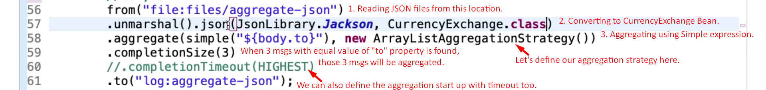
6. Let’s define our aggregation Strategy.Graphical user interface, text, application

   Description automatically generated
7. 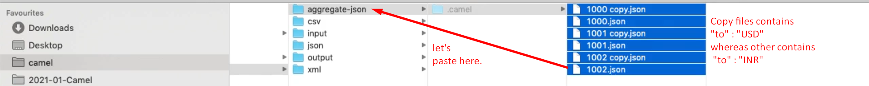
8. Text, letter

   Description automatically generated